TIME STANDARDS ACT

Written By

News Reporter Guy (NV)

**With Contributions By**

**Coca (OY)**

## SECTION ONE - SHORT NAME

TS ACT

OR

TSA

## SECTION TWO - ACT SUMMARY

*The following Act, when ratified by the Senate of the Vooperian Empire, shall provide consistent and reliable standards of time, for use by the Government and the Citizens of the Vooperian Empire.*

## SECTION THREE - TIME STANDARDS

### 3.1 - TIME ZONES

1. The domains of the Vooperian Empire on the planet SpookVooper shall be divided into Standardized Time Zones, or STZ
2. All STZ will be coordinated by their offset from the Senate Building in Vooperia City, whose longitude shall act as a Prime Meridian
3. The STZ of SpookVooper shall be as follows:
   1. Voopmont Standard Time (VST), offset from the Prime Meridian by -1.5 hours, and containing the entirety of the Districts of *Voopmont* and *Landing Cove*
   2. Spudland Standard Time (SST), offset from the Prime Meridian by -0.5 hours, and containing the entirety of the Districts of *New Spudland*, *Old King Peninsula*, and *Netherlands*
   3. City Standard Time (CST), offset from the Prime Meridian by 0 hours, and containing the entirety of the Districts of *New Yam* and *Vooperia City*
   4. Queensland Standard Time (QST), offset from the Prime Meridian by +1 hours, and containing the entirety of the Districts of *San Vooperisco*, *Corgi*, and *Queensland*
   5. Yam Standard Time (YST), offset from the Prime Meridian by +2 hours, and containing the entirety of the Districts of *Old Yam*, *Medievala,* and *New Vooperis*
   6. Insular Standard Time (IST), offset from the Prime Meridian by +3.5 hours, and containing the entirety of the Districts of *Isles of Servers Past* and *Los Vooperis*
4. The STZ *City Standard Time* shall also act as the Vooperian Coordinated Time (VCT), acting as the following: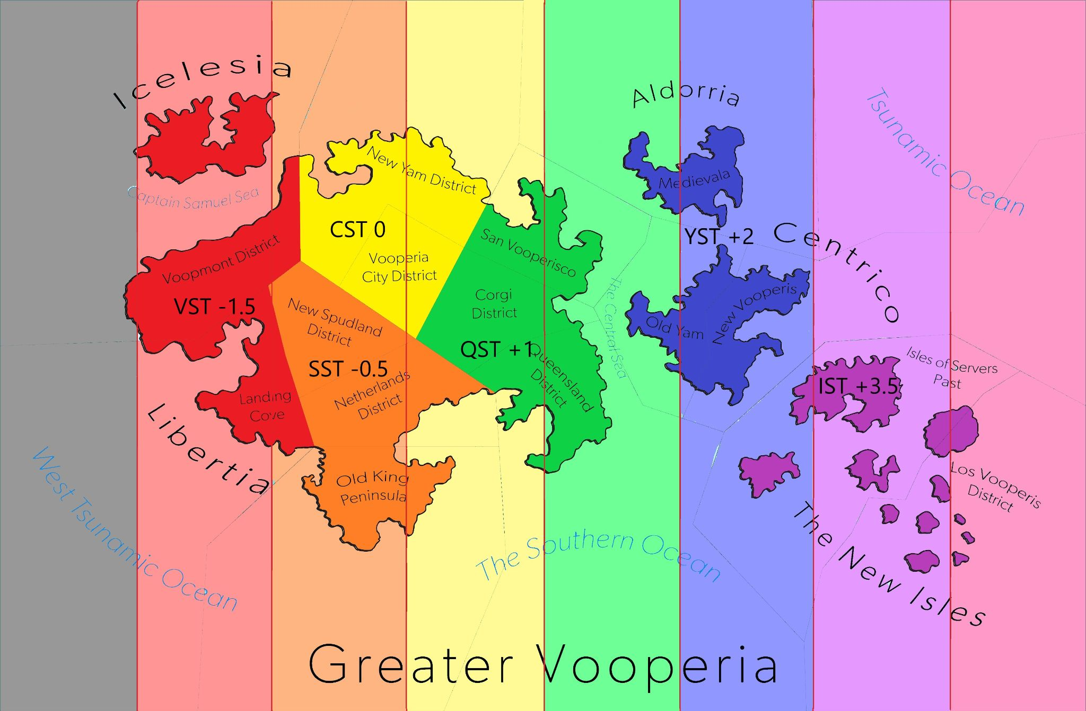
   1. As a worldwide time that both the Government and the Citizens can refer to as a generalization,
   2. As a time for use by the Government in whatever situations it deems a singular worldwide time to be of good use,
   3. As a time for which all other STZ can be derived from by adding or subtracting whole or fractions of hours,
   4. As a time for both Civilian and Government bodies to refer to when regarding matters of astronomy and/or interplanetary affairs

### 3.2 - DAYLIGHT SAVINGS TIME

1. All Districts will have the ability to activate Daylight Savings Time (DST) within their district, provided that
   1. The incumbent senator agrees
   2. The district is given 1 week before implementation of DST, which shall occur at
   3. 2:00 AM local time
2. All Districts will have the ability to deactivate Daylight Savings Time (DST) within their district, provided that
   1. The incumbent senator agrees
   2. The district is given 1 week before removal of DST, which shall occur at
   3. 3:00 AM local time
3. DST is hereby defined as:
   1. A moving of all clocks and other timekeeping devices within the affected area one hour forward for a period of time, which shall be defined as
   2. The time between 2:00 AM local time on the second Sunday of March, and
   3. 3:00 AM daylight time on the first Sunday of November
4. When a STZ is in DST or when referring to that situation the STZ
   1. Will have the *Standard* in its official name replaced with *Daylight*,
   2. Will have the *S* in its abbreviated name replaced with *D*

## SECTION FOUR - ENFORCEMENT AND MODIFICATION

### 4.1 - ENFORCEMENT

1. This Act may be enforced by the Senate, under the due process of law
2. This Act, when passed by the Senate, shall render the Government Unified Standardized Time Act null and void

### 4.2 - MODIFICATION

1. This act may be modified by the Senate, under the due process of law

END OF DOCUMENT